SIMATS ENGINEERING

Department of Computer Science and Engineering
ASSESSMENT TOOL 2 – DEBUGGING & OPTIMISATION TASK

Course Code: | CSA12 | Course Title: | Computer Architecture
CO Assessed: | CO2 – Precision (BL3) | Assessment: | Debugging and Optimisation task
Weightage: | 45% | Total Marks: | 100
CO2 Statement: | Apply integer and floating-point arithmetic algorithms including Booth's multiplication, restoring/nonrestoring division, and IEEE 754 standard operations to solve fixed-point and floating-point computational problems.
Student Name: | K.Rekanth | Reg. No.: | 192311213
Section / Batch: | CSE-2023 | Date: | 06-08-2026

Instructions to Students
- Identify arithmetic errors and performance bottlenecks in the given problem.
- Analyse the execution steps to locate the source of errors.
- Debug the algorithm by correcting logical and computational faults.
- Optimize the solution using appropriate arithmetic techniques or algorithms.
- Evaluate the optimized solution for correctness, accuracy, and efficiency.

QUESTIONS
- A program performing signed integer addition using 2’s complement produces incorrect results when adding large values (e.g., +120 and +50 in 8-bit representation). Debug the issue by analyzing the binary computation and identifying whether overflow has occurred. Propose a solution to correctly detect and handle overflow in such cases.
- A processor using a ripple carry adder shows significant delay in executing arithmetic operations in a realtime system. Debug the performance bottleneck by examining how carry propagates through each bit. Suggest an optimized solution using a carry look-ahead adder, and explain how it reduces delay.
- A multiplication unit implementing Booth’s algorithm gives incorrect results for certain negative operands. Debug the step-by-step execution of the algorithm, focusing on bit-pair checking, arithmetic shifts, and sign extension. Identify the possible source of error and suggest corrections to ensure accurate signed multiplication.
- An embedded system using the restoring division algorithm experiences inefficiency due to repeated restoration steps, leading to increased execution time. Debug the algorithm’s workflow and identify where unnecessary operations occur. Propose an optimized approach using the non-restoring division method, explaining how it improves performance.
- A scientific application using IEEE 754 single precision floating-point representation produces inaccurate results when adding very small and very large numbers. Debug the issue by analyzing exponent alignment, normalization, and rounding errors. Suggest optimization techniques, such as using double precision or algorithmic adjustments, to improve accuracy.

Code of Conduct
I K.Rekanth(192311213) certify that this submission is my original work and that I have adhered to the guidelines specified for this assessment. I understand that any violation of academic integrity rules will result in disciplinary action.
Signature of the Student: K.Rekanth

RUBRICS FOR CALCULATION

Criteria | Weightage(%) | Level 4 – Exemplary  (5 Marks) | Level 3 –  Proficient (4  Marks) | Level 2 – Developing  (2–3 Marks) | Level 1 – Beginning (0–1 Mark)
Identification of Errors /  Bugs | 20 | Accurately  identifies all  errors and issues with complete  understanding of the problem | Identifies most errors with minor omissions | Identifies limited errors; misses key issues | Unable to identify errors or  misunderstands the problem
Debugging  Approach & Analysis | 20 | Uses effective debugging  techniques with clear analysis  and root cause identification | Applies suitable debugging  methods with minor gaps | Uses basic debugging  methods with limited analysis | No systematic debugging  approach followed
Correctness of  Debugged  Solution | 25 | Provides completely corrected  solution with accurate  functionality and expected output | Provides working  solution with minor errors | Partially correct solution with limited functionality | Incorrect solution or fails to resolve errors
Optimization  Techniques Applied | 20 | Applies efficient optimization  methods to improve  performance,  memory usage and quality | Performs optimization  with noticeable improvements | Limited optimization with minimal improvements | No optimization applied or  inefficient implementation
Testing and Documentation | 15 | Performs complete testing with proper  validation and clear  documentation | Provides adequate testing and  documentation with minor issues | Limited testing and incomplete documentation | No proper testing or documentation provided

Marks Evaluation:

Q.  No | Identification of Errors / Bugs (20) |  | Debugging  Approach &  Analysis (20) | Correctness of Debugged  Solution (25) | Optimization  Techniques  Applied (20) | Testing and  Documentation  (15) | Total (out of 100)
1 | / 4 |  | / 4 | / 4 | / 4 | / 4
2 | / 4 |  | / 4 | / 4 | / 4 | / 4
3 | / 4 |  | / 4 | / 4 | / 4 | / 4
4 | / 4 |  | / 4 | / 4 | / 4 | / 4
5 | / 4 |  | / 4 | / 4 | / 4 | / 4
 | / 20 |  | / 20 | / 25 | / 20 | / 15 | / 100

Course Coordinator Faculty Incharge

1)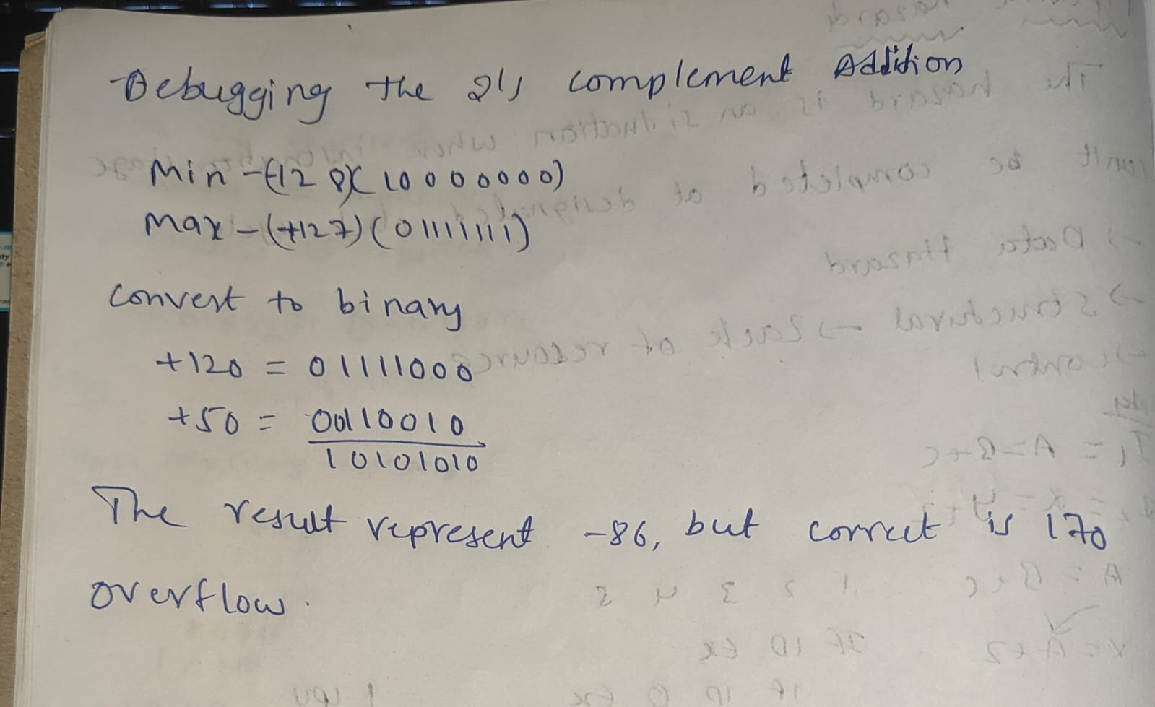

Reason:
Overflow occurs because the 8-bit signed range is -128 to +127, and 170 cannot be represented.
Solution:
- Detect overflow when two numbers with the same sign produce a result with the opposite sign.
- Raise an overflow flag or use a larger data type (16-bit/32-bit).
Conclusion:
The incorrect result is due to signed overflow. Detect overflow and use a larger integer type to handle such cases correctly.

2) 2. Ripple Carry Adder Delay
Problem:
A Ripple Carry Adder (RCA) is slow because each bit must wait for the carry from the previous bit before computing the sum.
Performance Bottleneck:
- Carry propagates sequentially from LSB to MSB.
- Total delay increases with the number of bits.
- Example: For an 8-bit RCA, delay = 8 × Full Adder delay.
Optimized Solution – Carry Look-Ahead Adder (CLA):
- CLA computes carry bits in parallel using Generate (G) and Propagate (P) signals.
- It does not wait for carry to ripple through each bit.
Advantages of CLA:
- Faster addition.
- Reduces carry propagation delay.
- Suitable for real-time and high-speed processors.
Conclusion:
The delay in a Ripple Carry Adder is caused by sequential carry propagation. Using a Carry Look-Ahead Adder (CLA) computes carries in parallel, significantly reducing delay and improving processor performance.

3. Booth's Algorithm Debugging
Problem:
The multiplication unit gives incorrect results when multiplying negative numbers using Booth's Algorithm.
Possible Sources of Error:
- Incorrect bit-pair checking (Q0 and Q-1).
- Wrong arithmetic right shift (sign bit not preserved).
- Improper sign extension for negative numbers.
- Incorrect initialization of Q-1 (should start as 0).
Corrections:
- Correctly apply Booth's rules:
  - 00 or 11 → No operation
  - 01 → Add Multiplicand (M)
  - 10 → Subtract Multiplicand (−M)
- Perform arithmetic right shift after every operation.
- Preserve the sign bit during shifting.
- Ensure proper 2's complement representation and sign extension for negative operands.
Conclusion:
Incorrect results are usually caused by errors in bit-pair checking, arithmetic shifts, or sign extension. Following Booth's rules correctly and preserving the sign bit ensures accurate signed multiplication.

4. Restoring Division Algorithm Debugging
Problem:
The Restoring Division Algorithm is slow because it repeatedly restores the previous value of the remainder after unsuccessful subtraction.
Inefficiency:
- Subtract divisor from remainder.
- If the remainder becomes negative, restore it by adding the divisor back.
- These repeated restoration steps increase execution time.
Optimized Solution – Non-Restoring Division:
- Does not restore the remainder immediately.
- If the remainder is negative, the next step performs addition instead of restoration.
- Reduces unnecessary operations and improves speed.
Advantages of Non-Restoring Division:
- Fewer arithmetic operations.
- Faster execution.
- Better performance for embedded and real-time systems.
- More efficient than the restoring division algorithm.
Conclusion:
The restoring division algorithm is slower due to repeated restoration operations. The non-restoring division algorithm eliminates these unnecessary restorations, resulting in faster and more efficient division.

5. IEEE 754 Floating-Point Representation Debugging

Problem:
A scientific application produces inaccurate results when adding very small and very large floating-point numbers.

Cause of Error:

Exponent alignment: The smaller number may lose significant digits when aligned with the larger number.

Normalization: The result is normalized, which can discard low-order bits.

Rounding: Rounding introduces small errors in the final result.

Optimized Solution:

Use double precision (64-bit) instead of single precision (32-bit) for higher accuracy.

Use algorithmic improvements such as Kahan Summation to reduce rounding errors.

Add numbers of similar magnitude whenever possible.

Advantages:

Higher precision and accuracy.

Reduced rounding and truncation errors.

Better results for scientific and engineering calculations.

Conclusion:
The inaccuracy is caused by exponent alignment, normalization, and rounding errors. Using double precision and improved summation algorithms significantly improves numerical accuracy.

